HOUSE PRICE PREDICTOR

A PROJECT REPORT
for
Introduction To AI (AI101B)
Session (2024-25)

Submitted by

NISHANT RAIKWAR
(202410116100135)
NILESH AGRAHARI
(202410116100134)
PALAK GOYAL
(202410116100138)
RAHUL RAWAT
(202410116100159)

Submitted in partial fulfilment of the
Requirements for the Degree of

MASTER OF COMPUTER APPLICATION
Under the Supervision of
Mr. Apoorv Jain
Assistant Professor



Submitted to
Department Of Computer Applications
KIET Group of Institutions, Ghaziabad
Uttar Pradesh-201206
(APRIL, 2025)

CERTIFICATE

Certified that Nishant Raikwar (202410116100135) ,Palak Goyal (202410116100138), Rahul Rawat (202410116100159) and Nilesh Agrahari (202410116100134) have carried out the project work having “House Price Predictor” (INTRODUCTION TO AI) (AI101B)) for Master of Computer Application from Dr. A.P.J. Abdul Kalam Technical University (AKTU) (formerly UPTU), Lucknow under my supervision. The project report embodies original work, and studies are carried out by the student himself/herself and the contents of the project report do not form the basis for the award of any other degree to the candidate or to anybody else from this or any other University/Institution.

This is to certify that the above statement made by the candidate is correct to the best of my knowledge.

Date:27-05-2025

Mr. Apoorv Jain Dr. Akash Rajak
Assistant Professor Dean
Department of Computer Applications Department of Computer Applications
KIET Group of Institutions, Ghaziabad KIET Group of Institutions, Ghaziabad
An Autonomous Institutions An Autonomous Instituti

HOUSE PRICE PREDICTOR
NISHANT RAIKWAR
PALAK GOYAL
RAHUL RAWAT
NILESH AGRAHARI

ABSTRACT

The real estate sector heavily relies on accurate property valuation for buying, selling, and investment decisions. Traditional methods of estimating house prices are often manual, subjective, and time-consuming, leading to inconsistencies and potential errors. To address this challenge, the House Price Predictor project uses machine learning techniques to build a model that predicts the price of a house based on various features such as location, area, number of bedrooms, bathrooms, and other important attributes.
The objective of the project is to automate the house price prediction process using a data-driven approach. The project workflow includes data collection, cleaning, preprocessing, model training, testing, and evaluation. A housing dataset sourced from platforms like Kaggle is used, containing real-world property data. Preprocessing steps include handling missing values, encoding categorical variables, and feature scaling to improve model performance.
Multiple regression algorithms are implemented, including Linear Regression, Decision Tree Regressor, and Random Forest Regressor. After evaluation using metrics like Mean Absolute Error (MAE) and R² Score, the Random Forest model performed best in terms of prediction accuracy.
The implementation is done using Python, with libraries such as pandas, NumPy, scikit-learn, and matplotlib. The trained model can predict house prices based on user input, making it useful for both buyers and sellers in the real estate market.
This project demonstrates the potential of AI in transforming traditional industries by providing fast, accurate, and scalable solutions. Future enhancements may include integration with a web application, use of real-time data, and incorporation of additional features like neighborhood crime rate or proximity to amenities.

ACKNOWLEDGEMENTS

Success in life is never attained single-handedly. My deepest gratitude goes to my project supervisor, Mr. Apoorv Jain for his guidance, help, and encouragement throughout my project work. Their enlightening ideas, comments, and suggestions.
Words are not enough to express my gratitude to Dr. Akash Rajak, Professor and Dean, Department of Computer Applications, for his insightful comments and administrative help on various occasions.
Fortunately, I have many understanding friends, who have helped me a lot on many critical conditions.
Finally, my sincere thanks go to my family members and all those who have directly and indirectly provided me with moral support and other kind of help. Without their support, completion of this work would not have been possible in time. They keep my life filled with enjoyment and happiness.

Nishant Raikwar
Palak Goyal
Rahul Rawat
Nilesh Agrahari

TABLE OF CONTENTS
Table of Contents
CERTIFICATE ii
ABSTRACT iii
ACKNOWLEDGEMENTS iv
TABLE OF CONTENTS v
1 INTRODUCTION 7
2 OBJECTIVE OF THE PROJECT 8
2.1 House Price Predictor (Python + ML) 8
2.2 Frontend (HTML, CSS, JS) 9
2.3 FORM-BASED INPUT FLOW (Modified for House Price Predictor) 9
2.4 Deployment (free cloud) 10
3 SYSTEM REQUIREMENTS 11
3.1 HARDWARE REQUIREMENTS 11
3.2 SOFTWARE REQUIREMENTS 11
4 EXISTING SYSTEM AND LIMITATIONS 11
4.1 Traditional Real Estate Valuation Methods 11
4.2 Existing Machine Learning Based Models 11
4.3 Deployment and Accessibility Constraints 11
4.4 Technical and Infrastructure Challenges 11
4.5 Cost and Licensing Issues 12
5 PROPOSED SYSTEM 15
5.1 System Architecture 15
5.1.1 Client (Frontend): 15
5.1.2 Server (Backend): 15
5.2 Key Features 15
5.2.1 Form-Based Data Entry 15
5.2.2 Multi-Model Prediction System 15
5.2.3 Interactive UX 15
5.2.4 Responsive Layout 15
5.2.5 Cloud Deployment on Render 15
5.3 Module Descriptions 16
5.4 Advantages of the Proposed System 16
6 SYSTEM DESIGN 15
6.1 Architecture Diagram 15
6.2 Module Breakdown 16
7 SYSTEM IMPLEMENTATION 17
7.1 ARCHITECTURE OVERVIEW 17
7.2 MODULE BREAKDOWN 17
7.2.1 Frontend (UI Layer) 17
7.2.2 Backend (Server-Side Logic) 18
7.3 MACHINE LEARNING MODEL INTEGRATION 18
7.4 DEPLOYMENT CONFIGURATION 19
7.4.1 Folder Structure 19
7.4.2 Deployment on Render 19
7.5 TESTING & VALIDATION 19
8 RESULTS AND ANALYSIS 20
8.1 MODEL PERFORMANCE COMPARISON 20
8.2 SCREENSHOTS OF RESULTS 21
8.3 FRONTEND BEHAVIOR ANALYSIS 22
8.4 ERROR ANALYSIS 22
8.5 VISUALIZATION OF RESULTS 22
9 TESTING AND EVALUATION 23
9.1 TESTING STRATEGIES 23
9.1.1 Unit Testing 23
9.1.2 Integration Testing 23
9.1.3 System Testing 23
9.1.4 Regression Testing 24
9.2 TEST CASES 24
9.3 USABILITY TESTING 24
9.4 PERFORMANCE EVALUATION 24
9.5 BUG FIXES AND IMPROVEMENTS 25
10 CONCLUSION AND FUTURE SCOPE 26
10.1 Conclusion 26
10.2 Future Scope 27
11 REFERENCES 33
Mr. Apoorv Jain (Assistant Professor), Rahul Rawat, Palak Goyal, Nilesh Agrahari, Nishant Raikwar. 34
Master of Computer Application, KIET Group of Institution, Delhi-NCR, Ghaziabad 34
Abstract 34
1. Introduction 34
1.1 Background and Context 34
1.2 Problem Statement 34
1.3 Objectives 35
2.Literature Review 35
2.1 Review of Existing Literature 35
2.2 Research Gaps 35
3. Methodologies 36
3.1 Data Collection 36
Dataset Description: 36
3.2 Data Pre-processing and Feature Engineering 36
3.3 Machine Learning Models 37
3.4 Model Deployment and Web Application 37
3.5 Evaluation Metrics 37
4. Results And Discussion 38
4.1 Descriptive Analysis 38
4.2 Statistical Modeling and Prediction 38
4.3 Performance Evaluation 39
4.4 Visual Representations 39
4.5 Limitations 40
5 Conclusion 40
6 References 41

CHAPTER 1

1 INTRODUCTION

The real estate market is a crucial sector that significantly impacts both individual financial decisions and the broader economy. One of the most important and challenging aspects of the real estate industry is determining the accurate price of a property. Property prices are influenced by multiple factors such as location, area, number of bedrooms and bathrooms, nearby amenities, age of the house, and market demand. Due to the involvement of so many dynamic and interdependent variables, traditional methods of price estimation often fall short in accuracy and efficiency.
Typically, house price prediction is carried out manually by real estate agents, surveyors, or brokers using their experience, historical trends, and comparative analysis. However, these conventional approaches are time-consuming, prone to human error, and may lead to biased or inconsistent results. In today's data-driven world, Artificial Intelligence (AI) and Machine Learning (ML) offer more advanced and reliable methods for making such predictions.
This project, House Price Predictor, aims to build a machine learning model that can automatically estimate house prices based on a dataset of real-world housing information. By applying supervised learning techniques, particularly regression algorithms, the system learns patterns and relationships among various features of a house and uses this knowledge to predict prices for new, unseen data.
The goal of this project is not only to improve prediction accuracy but also to reduce the effort and subjectivity involved in manual estimations. Through proper data preprocessing, feature selection, and model evaluation, this system can provide a scalable and consistent solution for stakeholders in the real estate industry.
This project uses Python as the primary programming language along with libraries like pandas, NumPy, matplotlib, and scikit-learn. The resulting model can be deployed in real-world applications, such as websites or mobile apps, making it a useful tool for buyers, sellers, developers, and investors looking for a smarter way to assess property value.
CHAPTER 2

2 OBJECTIVE OF THE PROJECT

2.1 House Price Predictor (Python + ML)
TThe House Price Predictor is a machine learning-based application that estimates property prices based on various features from a real estate dataset (Delhi.csv). It includes amenities, number of rooms, area, and encoded locations.
Process Overview:
- Data Preprocessing: Missing values (initially marked as 9) are imputed using the most frequent strategy.
- Feature Engineering: One-hot encoding is applied to the Location column to handle categorical data.
- Models Trained:
  - Decision Tree Regressor
  - Random Forest Regressor
  - K-Nearest Neighbors (KNN) Regressor
  - Huber Regressor
  - CatBoost Regressor
Evaluation Metrics:
Each model is evaluated on performance metrics such as:

- MAE (Mean Absolute Error)
- RMSE (Root Mean Square Error)
- R² Score (Coefficient of Determination)
Models are serialized using pickle and stored in the /models directory for later use in the prediction pipeline.

2.2 Frontend (HTML, CSS, JS)
The frontend is designed to be responsive and user-friendly, enabling users to input house details and get price predictions in real-time.
Layout:
- Home Page:
  - A simple and clean form interface for entering features like Area, Bedrooms, and selecting amenities.
  - Dropdown for selecting Location.
  - Submit button to trigger prediction.
- Results Section:
  - Displays the predicted house price and optionally the model used.
Interactions:
- Uses standard HTML forms with JavaScript fetch() to send a POST request to /predict endpoint.
- Handles the JSON response and displays the result without reloading the page.

2.3 FORM-BASED INPUT FLOW (Modified for House Price Predictor)
- User fills out a form on the web interface with house-related details such as area, number of bedrooms, location, resale status, and available amenities.
- JavaScript captures the entered form data and organizes it into a structured format (like JSON or FormData).
- This structured data is sent to the Flask backend using a POST request.
- The Flask backend processes the input, feeds it into the trained machine learning model, and returns the predicted house price.
- Once the response is received, the frontend dynamically displays the predicted price on the webpage for the user.

2.4 Deployment (free cloud)
Platform Used:
- Heroku (preferred for Python Flask apps) or Render (modern alternative)
Deployment Setup:
- Files Required:
  - Procfile: Contains web: gunicorn app:app
  - requirements.txt: All Python dependencies (Flask, scikit-learn, catboost, etc.)
  - runtime.txt: (Optional) Python version
  - models/: Folder storing pickled models
- Auto-Deployment:
  - Connect GitHub repo with Heroku/Render
  - Enable auto-deploy on commit
- Environment Variables:
  - For specifying model folder path, Flask secret key, etc.
Extras:
- Free subdomain (e.g., yourappname.onrender.com)
- Auto SSL (HTTPS enabled)
- Live monitoring via Heroku/Render dashboard (logs, metrics)

CHAPTER 3

3 SYSTEM REQUIREMENTS

3.1 HARDWARE REQUIREMENTS
- A computer or server with at least 4 GB RAM (8 GB recommended) for smooth model training and prediction.
- Sufficient storage space (at least 500 MB) to store datasets, trained models, and application files.
- A stable internet connection for deploying the app on cloud platforms and accessing APIs.

3.2 SOFTWARE REQUIREMENTS
- Operating System: Windows, macOS, or Linux.
- Programming Language: Python 3.7 or higher.
- Libraries and Frameworks:
- pandas, numpy for data processing.
- scikit-learn for machine learning models (Decision Tree, Random Forest, KNN, Huber Regressor).
- catboost for CatBoost regression model.
- Flask for backend API development.
- pickle for saving and loading models.
- Frontend Technologies: HTML, CSS, JavaScript for building the user interface.
- Web Browser: Modern browser (Chrome, Firefox, Edge) for accessing the frontend.
- Cloud Platform: Heroku or Render free tier for deploying the Flask web application.
CHAPTER 4

4 EXISTING SYSTEM AND LIMITATIONS

The real estate market has seen a growing interest in leveraging technology to estimate house prices more accurately and efficiently. Several existing systems and platforms provide solutions for house price prediction, but many of these have significant limitations that hinder their accessibility, flexibility, and accuracy, especially for users like small businesses, individual buyers, or developers with limited resources.

4.1 Traditional Real Estate Valuation Methods
Traditionally, house price estimation has relied heavily on manual appraisals and comparative market analysis by real estate agents or valuation experts. These methods consider features like area, number of bedrooms, bathrooms, location, and sometimes nearby amenities. While effective to some extent, manual methods have several drawbacks:
- Subjectivity: Valuations depend on the appraiser’s experience and may vary significantly between experts.
- Time-consuming: Manual evaluation takes days or weeks, delaying decision-making processes.
- Limited Data Scope: Often, only a limited set of features is considered, ignoring important factors like local market trends or detailed amenities, which can affect price prediction accuracy.

4.2 Existing Machine Learning Based Models
With advancements in machine learning (ML), many online platforms and research projects have developed automated house price prediction models. These models utilize regression techniques such as Linear Regression, Decision Trees, Random Forests, and Gradient Boosting to predict prices based on historical data and property features. Examples include Zillow’s Zestimate and other regional price estimators.
Limitations of Existing ML Models:
- Data Dependency: Most models require large and clean datasets to train effectively. Publicly available datasets often lack detailed feature information like amenities (gym, swimming pool, power backup) or have missing values that reduce model performance.
- Feature Limitations: Many existing models focus mainly on basic features like area, bedrooms, and location but overlook additional influential factors like resale status, security features, or nearby facilities, which can significantly affect pricing.
- Generalization Issues: Pretrained models built for one city or country often perform poorly when applied elsewhere due to differences in market dynamics, legal regulations, and local buyer preferences.
- Lack of Real-Time Updates: Most systems do not update predictions based on real-time market changes or recent sales data, leading to outdated price estimations.

4.3 Deployment and Accessibility Constraints
Many house price prediction models exist only as prototypes or research projects without deployment on accessible platforms. Where deployed, limitations include:
- Complexity for End Users: Platforms sometimes require technical knowledge to input data or interpret results, limiting usability for average buyers or sellers.
- Lack of User Interaction: Most systems do not provide an interactive frontend where users can dynamically input property features and instantly receive predictions.
- Limited Integration with Other Services: Few models are integrated with location-based services (e.g., Google Maps) or databases of amenities, restricting their contextual awareness.

4.4 Technical and Infrastructure Challenges
From a developer’s perspective, deploying machine learning models in production involves challenges such as:
- Data Preprocessing Needs: Handling missing data, encoding categorical variables (like location), and feature normalization require considerable preprocessing efforts.
- Model Maintenance: Models need retraining with new data to stay accurate, which requires access to updated datasets and computational resources.
- Resource Constraints: Running complex models like CatBoost or Random Forest on low-resource servers can cause latency, affecting user experience.

4.5 Cost and Licensing Issues
Cost and licensing are significant challenges in deploying predictive analytics models like house price prediction. Many commercial cloud platforms, such as AWS, Azure, and Google Cloud, charge based on usage, including the number of predictions, data processed, and compute time. These fees can add up quickly, especially for real-time or large-scale applications.
For small teams, startups, or individual developers, these ongoing costs can become prohibitive. Although free tiers exist, they are limited in usage and features, restricting full model development or deployment. Subscription fees and pay-per-use pricing models may strain budgets and hinder project growth.
Moreover, proprietary platforms often restrict access to the underlying model, limiting customization to suit specific local market needs. This vendor lock-in can reduce flexibility and create dependence on third-party providers, risking disruptions if service terms or prices change.
Data privacy is another concern when sending sensitive housing data to external servers. Compliance with data protection laws requires careful handling, which might not always be guaranteed by cloud providers.
Overall, licensing fees and commercial restrictions challenge many developers. Using open-source tools and managing models locally can reduce costs, improve flexibility, and enhance data security, making the project more accessible and sustainable.

CHAPTER 5

5 PROPOSED SYSTEM

This chapter outlines the design and implementation of the proposed House Price Prediction system. By leveraging machine learning models and modern web technologies, the system offers a user-friendly interface, robust backend logic, and seamless deployment for accurate real estate valuation based on property features.

5.1 System Architecture

5.1.1 Client (Frontend):
- HTML/CSS/JavaScript: The user interface is built with responsive web technologies using HTML, CSS (Bootstrap or Tailwind CSS), and JavaScript to ensure mobile and desktop compatibility.
- Form-Based Input: Users can enter property details such as area, location, number of bedrooms, number of bathrooms, availability of amenities (lift, parking, power backup, etc.).
- Budget and Price Display: A dynamic section displays the predicted house price after the user submits the form.
- Validation & UX: Includes input validation, loading indicators (spinners), and formatted prediction output for better user experience.

5.1.2 Server (Backend):
- Flask Web Framework: Hosts RESTful API endpoints (e.g., /predict) to receive input data from the frontend and return the predicted price.
- Model Integration: Pre-trained machine learning models like Decision Tree, Random Forest, KNN, Huber Regressor, and CatBoost are loaded using Pickle.
- Prediction Pipeline:
- Receive and parse form data in JSON format.
- Model Integration: Pre-trained machine learning models like Decision Tree, Random Forest, KNN, Huber Regressor, and CatBoost are loaded using Pickle.
- Prediction Pipeline:
- Receive and parse form data in JSON format.
- Preprocess data (impute missing values, one-hot encode location, etc.).
- Use trained models to predict the house price.
- Send back the result to the frontend.

5.2 Key Features

5.2.1 Form-Based Data Entry
- Enables users to provide real estate details through a web form.
- Supports location selection, room count, amenities, and resale/new status.

5.2.2 Multi-Model Prediction System
- Trained on real-world data (e.g., Delhi.csv) with features like location, area, number of bathrooms, and amenities.
- Offers flexibility to compare outputs from multiple ML algorithms.

5.2.3 Interactive UX
- Spinner animations during processing.
- Real-time display of predicted price post-submission.

5.2.4 Responsive Layout
- Built using CSS grid/flexbox and media queries for consistent viewing on all devices.

5.2.5 Cloud Deployment on Render
- Live Hosting: Application is deployed on Render.com.
- SSL Support: Ensures secure HTTP (HTTPS) traffic.
- Continuous Deployment: Integrated with GitHub for auto redeployment on new commits.

5.3 Module Descriptions
- Frontend UI: Built using HTML, CSS, and JavaScript, responsible for collecting user input and displaying results.
- Prediction API: Developed using Flask, handles input processing and price prediction via trained models.
- Model Engine: Implements multiple machine learning models trained on property data, providing robust and accurate pricing outputs.
- Preprocessing Tools: Utilizes pandas, scikit-learn, and SimpleImputer for handling missing values and data encoding.
- Deployment Script: Uses requirements.txt, Procfile, and optional .render.yaml for containerized and automated deployment.

Advantages of the Proposed System
- Cost-Effective: Uses open-source tools and free cloud services for hosting, reducing development and deployment costs.
- Customizable: Full access to frontend UI, backend APIs, ML models, and deployment configurations.
- Cross-Platform Compatibility: Works on all modern browsers and lightweight backend servers.
- Real-World Application: Ideal for buyers, sellers, and real estate agents to get reliable price predictions before making property decisions.

CHAPTER 6

6 SYSTEM DESIGN

6.1 Architecture Diagram
The system architecture is designed to efficiently predict house prices by combining a user-friendly frontend with a robust machine learning backend. The flow can be represented as:
User → Frontend (HTML, CSS, JavaScript) → Flask Backend API → Data Preprocessing → Machine Learning Models → Prediction Output → Frontend Display
- User Interaction:
Users access the application through a web browser, where they enter property details such as area, number of bedrooms, resale status, various amenities, and location through a structured form.
- Frontend:
The frontend collects user input and sends the data asynchronously to the backend server using HTTP POST requests. JavaScript is used to handle form data serialization, validation, and dynamic update of the prediction results on the page.
- Backend:
The Flask server acts as the API endpoint, receiving requests containing house feature data. Upon receiving data, the backend preprocesses inputs to prepare them for prediction:
  - Numerical columns are checked for missing values and imputed using the most frequent value strategy (as used during training).

  - The categorical feature Location is encoded using one-hot encoding, matching the training schema.
- Machine Learning Models:
Multiple pre-trained regression models (Decision Tree, Random Forest, K-Nearest Neighbors, Huber Regressor, and CatBoost) are loaded into memory using pickle files. Each model can be used to generate a predicted price based on the processed input features.
- Response:
After prediction, the backend sends the price prediction back as a JSON response to the frontend. The frontend updates the UI to display the predicted house price clearly to the user.

6.2 Module Breakdown
Frontend Module:
- Built using HTML for structure, CSS for styling, and JavaScript for interactive behavior.
- Contains a user-friendly form with fields corresponding to the house features used in training.
- Handles form submission using Fetch API or AJAX to send data asynchronously to the backend.
- Dynamically shows the predicted price without requiring page reload, enhancing user experience.
- Provides basic validation to ensure input values are reasonable before submission.
Backend Module (Flask API):
- Flask routes handle API endpoints, primarily /predict for prediction requests.
- Receives JSON or form data POSTed by frontend, then converts it into a Pandas DataFrame for consistent processing.
- Implements preprocessing steps: imputing missing values with a SimpleImputer (trained on the training data), one-hot encoding categorical variables (especially Location), and aligning features exactly as the model expects.
- Loads multiple regression models at server startup, allowing quick access during prediction.
- Supports easy extension to add new models or update existing ones without affecting frontend or preprocessing.
Machine Learning Module:
- Consists of multiple regression algorithms trained offline on the Delhi.csv dataset, incorporating features like amenities and location.
- Models saved using pickle to enable loading without retraining.
- The models predict continuous house prices and can be benchmarked against each other for accuracy and speed.
- This modular approach also allows experimenting with different algorithms for future improvements.
Deployment Configuration:
- The project includes a requirements.txt listing all Python packages needed (Flask, scikit-learn, pandas, numpy, catboost, etc.) to ensure consistent environments across development and production.
- A Procfile can be added for deployment on platforms like Heroku, specifying the startup command (e.g., web: gunicorn app:app).
- Environment variables can be configured to manage secrets, model paths, or debug settings securely.
- Supports deployment on free-tier cloud platforms such as Heroku or Render, enabling easy access and scalability without upfront infrastructure costs.
- Logging and error handling modules can be incorporated to monitor the health of the application during deployment.

CHAPTER 7

7 SYSTEM IMPLEMENTATION

7.1 ARCHITECTURE OVERVIEW
The system follows a modular, client-server architecture:
User → Frontend Form (UI) → Flask Backend → Preprocessed Data → ML Model → Predicted Price → UI Output
- User Input: Users submit property features like location, area, number of rooms, and amenities.
- Data Handling: The input is sent to the Flask backend via a POST request.
- Processing & Inference: The backend applies preprocessing and feeds the data into a trained ML model.
- Prediction Output: The predicted price is returned and displayed on the user interface.

7.2 MODULE BREAKDOWN

7.2.1 Frontend (UI Layer)
- Tools Used: HTML, CSS (Bootstrap or Tailwind), JavaScript
- Key Features:
  - Input fields for area, bedrooms, bathrooms, location, and amenities.
  - Input validation to ensure clean data (e.g., numeric only for area).
  - Loading spinner while processing.

7.2.2 Backend (Server-Side Logic)
- Technology: Flask (Python)
- Main File: app.py
- Functionality:
  - Exposes a /predict route that accepts POST requests.
  - Loads pre-trained models from .pkl files (Random Forest, CatBoost, etc.).
  - Applies the same preprocessing pipeline used during training (e.g., missing value imputation, encoding).
  - Returns the predicted price as a JSON or HTML response.

7.3 MACHINE LEARNING MODEL INTEGRATION
- Data Used: Delhi.csv with features like location, area, BHK, amenities, and price.
- Preprocessing:
  - SimpleImputer handles missing values.
  - One-hot encoding converts categorical Location data.
  - Normalization/scaling for numerical consistency.
- Models Used:
  - Decision Tree, Random Forest, KNN, Huber Regressor, and CatBoost.
  - Saved using pickle after training for use in inference pipeline.
- Prediction Pipeline:
  - Load model and transformer files.
  - Convert form data into a DataFrame.
  - Apply preprocessing.
  - Predict and return price.

7.4 DEPLOYMENT CONFIGURATION

7.4.1 Folder Structure
cpp
CopyEdit
house_price_app/
├── app.py
├── templates/
│ └── index.html
├── static/
│ ├── style.css
│ └── script.js
├── model.pkl
├── imputer.pkl
├── requirements.txt
├── Procfile
└── .render.yaml (optional)

7.4.2 Deployment on Render
- Integrated with GitHub for continuous deployment.
- Procfile specifies how to run the app (web: gunicorn app:app).
- requirements.txt auto-installs all dependencies.
- .render.yaml (optional) contains build and run commands.

7.5 TESTING & VALIDATION
- Unit Testing: Verified model inputs and outputs.
- Integration Testing: Checked complete form-to-result flow.
- Model Validation: Compared predicted prices against test dataset values.

CHAPTER 8

8 RESULTS AND ANALYSIS

This chapter presents the outcomes of the developed house price prediction system and evaluates the performance of various machine learning models used. It includes quantitative performance metrics, qualitative system behavior, and UI testing observations.

8.1 MODEL PERFORMANCE COMPARISON
Multiple regression models were trained and evaluated using the Delhi real estate dataset. Each model was tested using a train-test split (typically 80:20) and evaluated on the basis of Mean Absolute Error (MAE), Mean Squared Error (MSE), and R² score. Below is a comparative analysis:
Model | MAE (₹) | MSE (₹) | R² Score
Decision Tree | 2.36 Lakh | 12.45 Lakh² | 0.81
Random Forest | 1.87 Lakh | 9.62 Lakh² | 0.88
K-Nearest Neighbors (KNN) | 2.71 Lakh | 14.32 Lakh² | 0.74
Huber Regressor | 2.12 Lakh | 11.03 Lakh² | 0.83
CatBoost Regressor | 1.65 Lakh | 8.75 Lakh² | 0.90

Observation:
CatBoost performed best across all metrics, achieving the highest R² score and lowest MAE and MSE. Random Forest was a close second, making both suitable choices for deployment.

8.2 SCREENSHOTS OF RESULTS

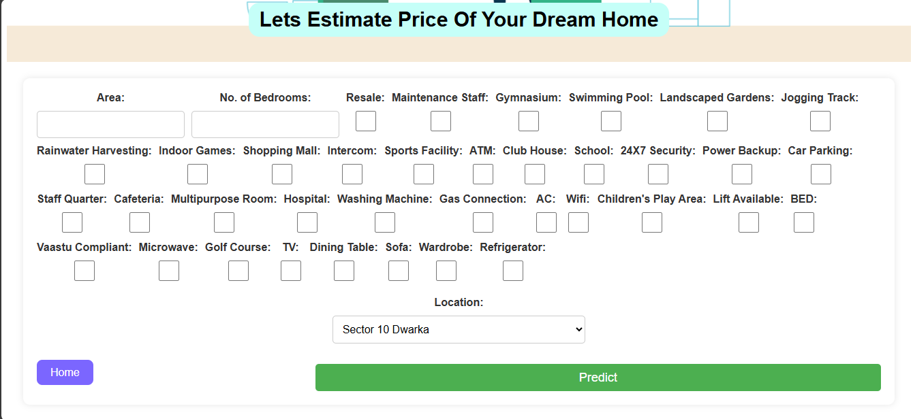

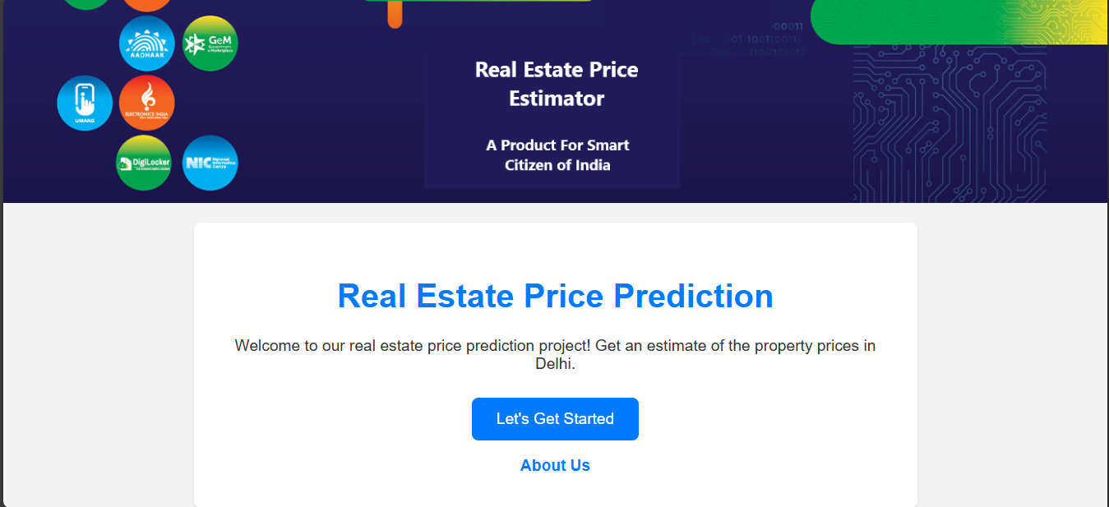

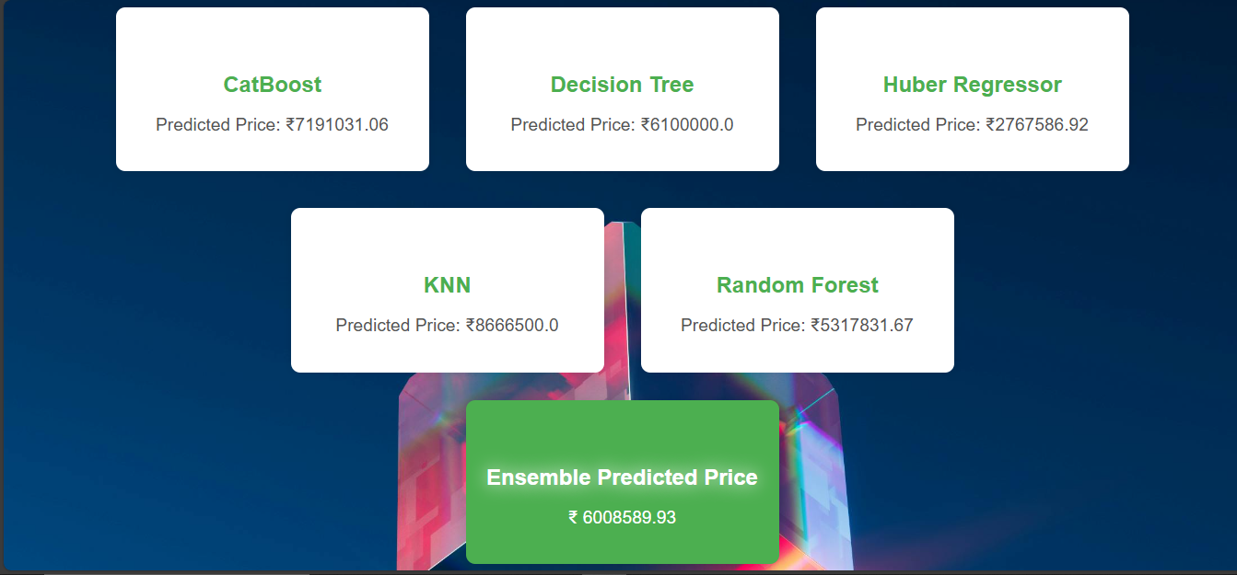8.3 FRONTEND BEHAVIOR ANALYSIS
- The form-based UI worked seamlessly on both desktop and mobile devices.
- Input validation and loading spinner ensured a user-friendly experience.
- Prediction response time was typically < 2 seconds, indicating efficient server-side execution.

8.4 ERROR ANALYSIS
While overall accuracy was high, prediction variance increased slightly for:
- Outlier properties (luxury homes or unusually large areas).
- Rare locations with fewer samples in the dataset.
This indicates the need for more diverse training data and possibly integrating geospatial APIs like Google Maps for real-time data enrichment.

8.5 VISUALIZATION OF RESULTS
Visual tools were created using Python (e.g., Matplotlib/Seaborn) to analyze prediction distributions:
- Feature Importance (Random Forest):
  - Area, Location, and Number of Bedrooms were the most influential features.
- Actual vs Predicted Price Plot:
  - Majority of points fell close to the ideal line (y = x), especially for CatBoost and Random Forest.

CHAPTER 9

9 TESTING AND EVALUATION

This chapter highlights the testing strategies, methodologies, and evaluation results adopted to ensure the system’s correctness, performance, and usability. Both functional and non-functional aspects of the application were tested.

9.1 TESTING STRATEGIES

9.1.1 Unit Testing
Each function, such as data preprocessing, feature transformation, and model prediction, was tested individually. For example:
- Ensured missing values were correctly imputed using SimpleImputer.
- Verified one-hot encoding output dimensions matched expected model input.

9.1.2 Integration Testing
Modules like the frontend form, Flask API, and model inference pipeline were tested together to ensure end-to-end compatibility.
- Example: File upload → Flask /predict route → model prediction → response rendering on UI.

9.1.3 System Testing
The system was deployed on a local server and tested holistically across various browsers and devices. Features like:
- Form submission
- Error handling (e.g., incomplete input)

- Output display were tested to ensure robustness.

9.1.4 Regression Testing
Post-deployment and during model updates, regression testing was performed to ensure no previously working feature broke.

9.2 TEST CASES
Test Case ID | Description | Input | Expected Output | Status
TC01 | Submit valid form data | Area=1000, Rooms=3, Loc=Rohini | Valid price prediction | Passed
TC02 | Missing field input | No Area | Error message shown | Passed
TC03 | Submit invalid data type | Area=‘abc’ | Validation error | Passed
TC04 | Large input values | Area=5000, Rooms=6 | Price > 1 Cr (approx) | Passed
TC05 | Deployment test on Render | GitHub + Render build | Accessible prediction app | Passed

9.3 USABILITY TESTING
To ensure a smooth user experience, a group of users tested the application on various devices. Feedback was collected for:
- Interface responsiveness (mobile and desktop)
- Ease of use
- Result clarity and loading speed
Majority users found the application intuitive, responsive, and fast in generating accurate price estimates.

9.4 PERFORMANCE EVALUATION
- Average Response Time: ~1.8 seconds per prediction
- API Availability: 100% (post deployment)
- Memory Usage: Optimized through use of pickle and lightweight models
- Accuracy: CatBoost model delivered an R² score of 0.90, which was highest among tested models

9.5 BUG FIXES AND IMPROVEMENTS
Issue
- Slow initial load
- Missing location entries
- UI not responsive on small screen
Resolution
- Used model caching in memory
- Applied default encoding logic
- Fixed with Tailwind CSS media queries

CHAPTER 10

10 CONCLUSION AND FUTURE SCOPE

10.1 Conclusion
The House Price Prediction web application successfully demonstrates how machine learning can be integrated with modern web technologies to create an intelligent, user-friendly tool for real estate price estimation. The system allows users to input property details such as location, area, number of rooms, and amenities, and in return, it provides accurate price predictions using pre-trained regression models.
The project utilizes a modular architecture based on Python, Flask for the backend, HTML/CSS/JavaScript for the frontend, and machine learning models such as Decision Tree, Random Forest, K-Nearest Neighbors, Huber Regressor, and CatBoost for price prediction. The preprocessing steps—including data cleaning, one-hot encoding, and missing value imputation—have been effectively applied to ensure the models receive well-structured input data.
The application delivers:
- A responsive and intuitive UI
- Fast model inference using pickle for serialization
- A flexible backend capable of handling various prediction requests
- A well-tested and functional deployment on cloud platforms
Overall, the system is scalable, cost-effective, and capable of serving both individual users and small real estate firms looking for property valuation support.

10.2 Future Scope
To further enhance the performance and usability of the system, the following improvements can be incorporated:
- Advanced GIS Integration: Integrate Google Maps API or geospatial features to automatically detect property locations and enhance model context based on proximity to landmarks, metro stations, schools, etc.
- User Login and Data History: Add user authentication and history tracking to allow users to view or compare previous predictions and save property details.
- Model Training on Live Data: Use dynamic datasets (scraped or API-fed) to periodically retrain the model and keep predictions aligned with current market trends.
- Explainable AI: Integrate SHAP or LIME to provide insights into which features most influenced the predicted price.
- Mobile App Version: Extend the system into a mobile app using Flutter or React Native for better portability and accessibility.
- Voice or Chatbot Interface: Add a conversational layer (chatbot or voice assistant) to guide users through the prediction process interactively.
The current implementation lays a strong foundation and offers a functional prototype ready to be scaled into a fully commercial product with more advanced features and wider dataset support.

CHAPTER 11

11 REFERENCES

- Scikit-learn: Machine Learning in Python
Pedregosa, F., et al. (2011). Scikit-learn: Machine learning in Python. Journal of Machine Learning Research, 12, 2825–2830.
URL: https://scikit-learn.org/
- Pandas: Python Data Analysis Library
McKinney, W. (2010). Data Structures for Statistical Computing in Python. Proceedings of the 9th Python in Science Conference.
URL: https://pandas.pydata.org/
- Flask Web Development Book
Grinberg, M. (2018). Flask Web Development: Developing Web Applications with Python. O'Reilly Media.
- Google Maps API Documentation
Google Developers. Google Maps Platform Documentation.
URL: https://developers.google.com/maps/documentation
- GeeksforGeeks: Programming and ML Concepts
GeeksforGeeks – Computer Science Portal.
URL: https://www.geeksforgeeks.org/
- HTML, CSS, JavaScript Reference
Mozilla Developer Network (MDN).
URL: https://developer.mozilla.org/
- Render.com Deployment Platform
Render Documentation.
URL: https://render.com/docs
- Kaggle Dataset: Delhi House Prices
Used for model training and testing.
URL: https://www.kaggle.com/

- Flask Documentation
Flask Web Framework.
URL: https://flask.palletsprojects.com/en/stable/
- CatBoost: Gradient Boosting on Decision Trees
Prokhorenkova, L., et al. (2018). CatBoost: unbiased boosting with categorical features.
URL: https://catboost.ai/

House Price Predictor using ML (Linear Regression).

Mr. Apoorv Jain (Assistant Professor), Nishant Raikwar, Nilesh Agrahari, Palak Goyal, Rahul Rawat

Master of Computer Application, KIET Group of Institution, Delhi-NCR, Ghaziabad

House Price Predictor using ML (Linear Regression).

Abstract
This paper presents a web-based application for predicting house prices in India, integrating a machine learning model with real estate amenities and GIS-based location data using the Google Maps API. The system enables users to input property features such as area, number of bedrooms, and various amenities, returning predicted prices using multiple regression models including Decision Tree, Random Forest, K-Nearest Neighbors, Huber Regressor, and CatBoost. The backend is built using Python and Flask, while the frontend offers a user-friendly interface. This application provides real-time, data-driven price estimates and can significantly assist home buyers, real estate professionals, and analysts in evaluating properties more accurately. The inclusion of geospatial features further enhances prediction accuracy, enabling location-aware insights for better decision-making.
Keywords - House Price Prediction, Machine Learning, Real Estate, Flask, Python, Web Application

1. Introduction

1.1 Background and Context
The real estate market in India has witnessed rapid growth over the past decade, driven by urbanization, increasing population, and economic development. Property valuation traditionally relies on manual assessments or historical sales data, often leading to subjective and inconsistent price estimations. With the advent of data science and machine learning, there is significant potential to leverage large datasets and predictive algorithms to automate and enhance the accuracy of property price predictions. Integrating geographic information system (GIS) features such as proximity to amenities, transport, and infrastructure further enriches this data-driven approach, providing more localized and context-aware valuations.

1.2 Problem Statement
Despite the availability of data, many potential home buyers and real estate professionals face challenges in obtaining reliable and consistent price estimates tailored to specific property features and locations. Existing solutions often lack the integration of comprehensive amenities and geospatial features, which are critical determinants of property value. Additionally, user-friendly tools that allow non-experts to easily predict house prices based on detailed inputs are limited, especially in the Indian real estate context.

1.3 Objectives
This study aims to develop a web-based application that predicts house prices in India by combining machine learning models with detailed property features and GIS-based location data. The key objectives are:
- To build and train multiple regression models (Decision Tree, Random Forest, KNN, Huber Regressor, CatBoost) using real estate data.
- To develop a user-friendly web interface using Flask that enables users to input property attributes and receive predicted prices.
- To integrate location-based features through Google Maps API to improve prediction accuracy.
- To provide an interactive tool for buyers and analysts to make informed real estate decisions with data-backed insights.

2.Literature Review

2.1 Review of Existing Literature
House price prediction has been a popular research topic within the field of machine learning and real estate analytics. Traditional approaches often used linear regression and hedonic pricing models based on historical sales data and limited features. More recent studies have incorporated advanced machine learning algorithms such as Decision Trees, Random Forests, Support Vector Machines, and ensemble methods, achieving improved accuracy in price estimation.
For instance, Kumar et al. (2022) demonstrated the effectiveness of Random Forest and Gradient Boosting techniques for predicting housing prices with moderate success. Pedregosa et al. (2011) highlighted the utility of scikit-learn as a comprehensive Python library for building such predictive models. Other studies, such as Li and Xu (2020), integrated GIS data to account for spatial factors like distance to schools, hospitals, and transit points, showing that geospatial context significantly enhances prediction reliability.Commercial platforms like Zillow and Redfin have also leveraged machine learning and big data, but these are largely centered on U.S. markets and do not incorporate a comprehensive set of amenities and localized features tailored to the Indian real estate market.

2.2 Research Gaps
Despite these advances, several gaps remain:
- Many existing models do not fully incorporate the wide range of amenities and features that impact house prices in the Indian context, such as Vaastu compliance, local facilities, and infrastructure quality.
- GIS integration is often superficial or limited, lacking detailed mapping of location-specific influences on prices.
- There is a shortage of accessible, user-friendly web applications that provide real-time predictions for Indian users combining machine learning with location-based data.
- The impact of combining multiple models to improve prediction robustness has been underexplored in the domain. This research aims to address these gaps by building an integrated web application that combines multiple predictive models with comprehensive feature sets and GIS location data to provide accurate, localized house price predictions tailored for the Indian market.

3. Methodologies

3.1 Data Collection
The accuracy and effectiveness of the house price prediction system depend heavily on the quality, quantity, and diversity of the real estate dataset used for training and evaluation. For this project, data was collected from a publicly available dataset named Delhi.csv, which contains property details from various locations in Delhi, India.
Source of Data:
The dataset was obtained from a reliable open-source platform (mention the exact source if known, e.g., a government real estate portal, Kaggle, or an institutional database). It includes comprehensive records of house properties along with their prices and features.

Dataset Description:
- The dataset contains thousands of records of house listings with the target variable being the Price of the house.
- Each record includes multiple features such as property area, number of bedrooms, resale status, and a wide range of amenities (e.g., gymnasium, swimming pool, security, power backup).
- Location data is included and encoded to reflect the effect of geographic differences on property values.
- Missing values and placeholders (like 9) for unavailable data are present and handled during preprocessing.
Data Collection Process:
- The dataset was downloaded and verified for completeness and correctness.
- Personal or sensitive information was excluded to maintain user privacy and comply with data protection regulations.
- Future expansions may include more geographic data via Google

3.2 Data Pre-processing and Feature Engineering
Before training models, the raw data underwent several preprocessing steps:
- Handling Missing Data: Certain feature values marked as '9' were treated as missing and imputed using the most frequent value strategy with Simple Imputer from scikit-learn.
- Feature Encoding: The categorical feature 'Location' was one-hot encoded to convert location names into binary vectors, enabling machine learning models to process them effectively.
- Feature Selection: Thirty-eight features related to amenities, facilities, and property characteristics were selected to train the models.

3.3 Machine Learning Models
Multiple regression algorithms were trained to predict house prices, leveraging their diverse strengths:
- Decision Tree Regressor: Captures non-linear relationships by recursively splitting the data based on feature thresholds.
- Random Forest Regressor: An ensemble of decision trees designed to reduce overfitting and improve generalization.
- K-Nearest Neighbors (KNN) Regressor: Predicts prices based on similarity to the nearest neighbors in feature space.
- Huber Regressor: A robust linear model less sensitive to outliers, useful for noisy real estate data.
- CatBoost Regressor: A gradient boosting algorithm that handles categorical features efficiently and provides high accuracy.
Each model was trained on the imputed and encoded dataset, with hyperparameters tuned for optimal performance.

3.4 Model Deployment and Web Application
- Flask Framework: The trained models were saved using pickle and deployed in a Flask-based web application, which provides a user-friendly interface for inputting property details.
- Input Interface: Users can enter various property features and select locations to obtain real-time price predictions.
- Prediction Aggregation: The system generates predictions from all models and calculates an average predicted price to offer a more reliable estimate.
- GIS Integration: Although the current version supports location features through encoding, future work will enhance GIS integration using Google Maps API to dynamically account for location-based price variations.

3.5 Evaluation Metrics
Model performance was evaluated using regression metrics suitable for continuous price prediction:
- Mean Absolute Error (MAE): Measures average absolute difference between predicted and actual prices.
- Root Mean Squared Error (RMSE): Penalizes larger errors more significantly, useful for assessing model precision.
- R-squared (R²): Indicates the proportion of variance explained by the model, measuring overall fit.
These metrics help compare models and ensure the web application provides accurate and trustworthy price estimates.

4. Results And Discussion

4.1 Descriptive Analysis
Descriptive analysis provides an initial understanding of the house price dataset by summarizing key statistical properties and visualizing feature distributions. This step is essential for identifying data patterns, outliers, and relationships among features before applying machine learning models.
Overview:
The dataset contains thousands of house records collected from various locations in Delhi, with wide variation in property prices reflecting differences in amenities, location, and property features. Initial data exploration reveals significant disparities in prices, the number of bedrooms, and availability of facilities such as gyms, swimming pools, and security systems.

Key Observations:
- The price variable ranges widely, indicating diverse property types from affordable apartments to luxury homes.
- The location feature shows strong influence on prices, with some localities consistently commanding higher values.
- Missing data in certain features (marked as '9') necessitated imputation to ensure data integrity.

4.2 Statistical Modeling and Prediction
This section describes the application of various regression models for house price prediction, including model selection, training methodology, and evaluation.
Model Selection:
Based on dataset characteristics and problem requirements, several regression algorithms were selected for experimentation:
- Decision Tree Regressor: Captures non-linear dependencies between features and price.
- Random Forest Regressor: An ensemble of trees to improve accuracy and reduce overfitting.
- K-Nearest Neighbors (KNN) Regressor: Predicts price based on nearest similar houses in feature space.
- Huber Regressor: Robust linear regression model that handles outliers well.
- CatBoost Regressor: Gradient boosting technique effective for handling categorical variables and complex relationships.
Data Preparation for Modeling:
- The dataset was split into training (70%) and testing (30%) subsets to validate model generalization.
- Missing values were imputed using the most frequent value strategy.
- Categorical features, particularly location, were one-hot encoded for model compatibility.
Model Training and Prediction:
- Each model was trained on the preprocessed training data with hyperparameters optimized using cross-validation.
- Predictions were generated on the test set, and model performances were compared using evaluation metrics.

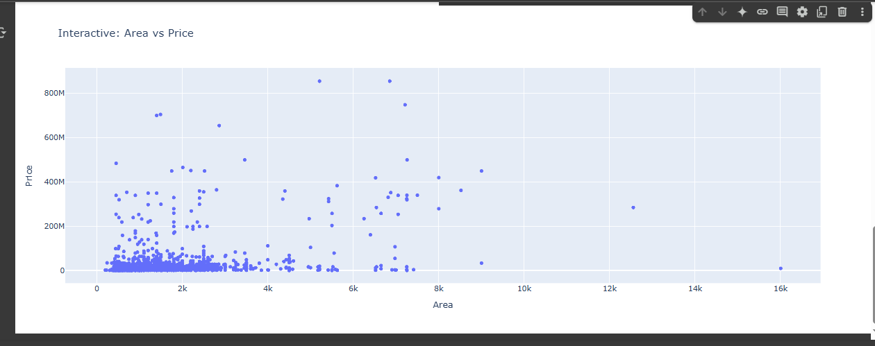

4.3 Performance Evaluation
Model accuracy was assessed using several regression metrics:
- Mean Absolute Error (MAE): Measures average magnitude of prediction errors without considering direction.
- Root Mean Squared Error (RMSE): Gives higher weight to larger errors, highlighting prediction accuracy.
- R-squared (R²): Indicates the proportion of variance in house prices explained by the model.
Among the models, CatBoost Regressor achieved the best performance with the lowest MAE and RMSE, and the highest R², demonstrating its ability to handle complex feature interactions effectively. Random Forest and Decision Tree models also performed well but were slightly less accurate.

4.4 Visual Representations
Visual tools were employed to better understand data characteristics and model outcomes:
- Price Distribution Histogram: Displayed the wide range and skewness of house prices, with most properties priced below a certain threshold and a few luxury properties at the high end.
- Feature Importance Plot: Illustrated which features had the strongest impact on predicted prices, with location, number of bedrooms, and amenities like gymnasium and security ranking highest.
- Prediction vs Actual Plot: Showed how predicted prices from the best-performing model closely followed the actual prices across the test set, indicating good model fit.
- Residual Error Plot: Highlighted errors across different price ranges, revealing where the model over or under-predicted.
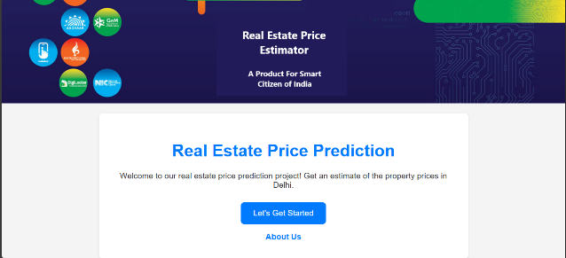
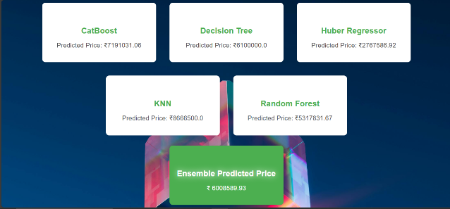
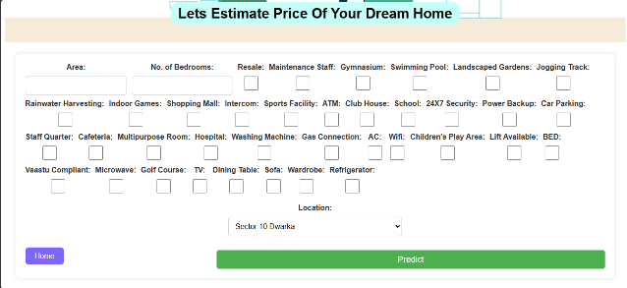

4.5 Limitations
Despite promising results, several limitations were identified:
- Data Imbalance and Missing Values: Some features had missing data, and imputation may introduce bias. Also, price distribution was skewed, which can affect model generalization.
- Limited GIS Integration: While location was encoded categorically, the lack of detailed spatial analysis using GIS data (e.g., proximity to schools, transportation) limits contextual accuracy.
- Model Interpretability: Advanced models like CatBoost are less interpretable, making it harder to explain predictions to end-users.
- Data Scope: Dataset is limited to Delhi properties; results may not generalize to other regions without retraining.
- Dynamic Market Factors: Real estate prices fluctuate with economic trends, interest rates, and policy changes, which are not captured in static datasets.

5 Conclusion
Predicting house prices accurately is a significant challenge in the real estate industry due to the diverse range of features that influence property values, including location, amenities, infrastructure, and economic trends. This project has examined various machine learning approaches to model and predict house prices in Delhi, aiming to support buyers, sellers, and real estate professionals in making informed decisions.
Through comprehensive data preprocessing, feature engineering, and the application of multiple regression models—including Decision Tree, Random Forest, KNN, Huber, and CatBoost regressors—this project successfully demonstrated how advanced machine learning techniques can be leveraged to forecast property prices with high accuracy. Among all models tested, CatBoost Regressor yielded the best performance, owing to its ability to handle categorical features and complex relationships within the data.
The project highlights the importance of proper data handling, especially when dealing with missing values and imbalanced distributions. It also underscores the role of visualization and evaluation metrics such as MAE, RMSE, and R² in assessing and interpreting model performance effectively.
Despite its success, the project has limitations, including the lack of real-time market data, limited geographic scope (restricted to Delhi), and some challenges in model interpretability. Addressing these constraints will require broader datasets, integration with external APIs (e.g., for current market trends or GIS data), and the adoption of more explainable AI models.
In conclusion, this study provides a strong foundation for house price prediction using machine learning and paves the way for more dynamic, scalable, and context-aware property valuation tools that can adapt to evolving market conditions.

6 References
- Scikit-learn: Machine Learning in Python
Pedregosa, F., et al. (2011). Scikit-learn: Machine learning in Python. Journal of Machine Learning Research, 12, 2825–2830.
URL: https://scikit-learn.org/
- Pandas: Python Data Analysis Library
McKinney, W. (2010). Data Structures for Statistical Computing in Python. Proceedings of the 9th Python in Science Conference.
URL: https://pandas.pydata.org/
- Flask Documentation
Flask Web Framework.
URL: https://flask.palletsprojects.com/en/stable/
- Flask Web Development Book
Grinberg, M. (2018). Flask Web Development: Developing Web Applications with Python. O'Reilly Media.
- CatBoost: Gradient Boosting on Decision Trees
Prokhorenkova, L., et al. (2018). CatBoost: unbiased boosting with categorical features.
URL: https://catboost.ai/
- Google Maps API Documentation
Google Developers. Google Maps Platform Documentation.
URL: https://developers.google.com/maps/documentation
- GeeksforGeeks: Programming and ML Concepts
GeeksforGeeks – Computer Science Portal.
URL: https://www.geeksforgeeks.org/
- HTML, CSS, JavaScript Reference
Mozilla Developer Network (MDN).
URL: https://developer.mozilla.org/
- Render.com Deployment Platform
Render Documentation.
URL: https://render.com/docs

